Day 21_ Insurance Claims Analysis
A real-world SQL coding challenge on subqueries using an insurance dataset
CREATE TABLE claims ( claim_id INT, policy_holder VARCHAR(50), policy_type VARCHAR(50), claim_amount INT, claim_date DATE, status VARCHAR(20)
);
INSERT INTO claims VALUES
(1, 'Ravi', 'Health', 50000, '2024-01-10', 'Approved'),
(2, 'Anita', 'Vehicle', 20000, '2024-01-12', 'Rejected'),
(3, 'Ravi', 'Health', 30000, '2024-01-20', 'Approved'),
(4, 'Suresh', 'Life', 100000, '2024-01-25', 'Approved'),
(5, 'Anita', 'Vehicle', 15000, '2024-02-01', 'Approved'),
(6, 'Kiran', 'Health', 40000, '2024-02-10', 'Rejected'),
(7, 'Ravi', 'Health', 70000, '2024-02-15', 'Approved'),
(8, 'Suresh', 'Life', 50000, '2024-02-20', 'Rejected');
Task 1:
Find claims where claim amount is greater than average claim amount
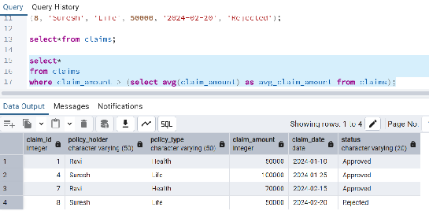
Task 2:
Find policy holders who have at least one approved claim
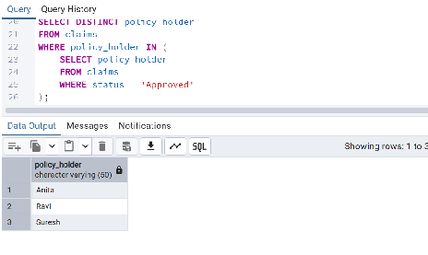
Task 3:
Find claims where claim amount is greater than that policy holder’s average claim
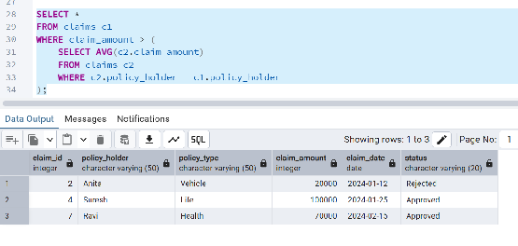
Task 4:
Display each claim along with overall average claim amount
